Inquiry into the Treatment of Individuals Suspected of People Smuggling Offences who Say They are Children.

Discussion Paper

Australian Human Rights Commission

Submission on behalf of :-

DR STEPHEN KNOTT OAM

FORENSIC ODONTOLOGIST
Consultant to PathWest
Assoc. Professor
University of Western Australia
CONTENTS

Statement 3
Introduction 3
Background 3
Biological Process 4
Technology for Determining Age Assessment 5
Chronological Age Related to Dental Radiographic Images 5
Exposure to Radiation 6
Utilisation of Hand/Wrist Radiographs 6
Standard Operational Protocol for Age Assessment 6
Conclusions 7
References 9
Image 1 OPG at 6 years 3 months 13
Image 2 OPG at 14 years 10 months 13
Image 3 OPG at 17 years 2 months 14
Image 4 OPG at 19 years 14
Image 5 OPG Machine 15
Image 6 Stages of Crown Root Formation 16
Appendix 1 A Critical Assessment of Human Age at Death Estimation 17
Appendix 2 Schour & Massler Atlas 21
Appendix 3 Blenkin & Taylor Atlas 22
Appendix 4 Al Quhtani Atlas 23
Appendix 5 Radiation Dosage 24
Appendix 6 Draft Report – Generic 25

Statement

I believe the following statement summarises our current knowledge.

“Dental age assessment is not precise but it provides a realistic quantifiable estimate of age which is not matched by other methods” [1]

Introduction

I make this submission to the Inquiry as a National Dental Board registered specialist Forensic Odontologist.

I currently hold the position of Associate Professor in Forensic Odontology to the Faculty of Medicine, Dentistry and Heath Science, University of Western Australia.

I am also the consultant Forensic Odontologist to PathWest, WA Health Services, a position I have held since 1991.

I am a member and Immediate Past President of the Australian Society of Forensic Odontology.

Background

Development of the dentition (teeth) has been a recognised indicator of an individual’s chronological age for centuries [2]. Historically the age assessment was related to the eruption of teeth into the mouth. Since the inception of radiographic technology last century, the various stages of tooth formation (termed “maturation”) can be recorded and monitored. The maturation process commences “in utero” – before birth and continues until a young adult. Also radiographic analysis of the adult dentition can be a broad indicator of age throughout adult life [3 – 18].
This technique of age assessment is in common use around the world within the fields of general and forensic dentistry, orthodontics, paediatric dental specialists and team consultations in paediatric medicine. The technique has been invaluable in regular forensic investigations and mass disaster identifications.
Personally, I incorporate the assessment process in day to day case work. I also relied heavily upon the technique when working as a Forensic Odontologist following the Asian tsunami in 2005, Victoria bushfires in 2009 and the wreck of SIEV 221 on Christmas Island in 2010.
The findings of Australian and New Zealand Police Advisory Agency/National Institute of Forensic Science medical sciences workshop held in Adelaide in May 2010 can be found in Appendix 1.

Biological Process

Basically specific embryonic tissue within the human body called “tooth germs”, mature in a predictable genetically controlled pattern until all of the teeth have been fully formed. Image 1 – 4.
The maturation process involves the mineralisation of the “tooth germs” commencing at the tip of the tooth cusp (biting edge) and proceeding to the closure of the root apex (tip of root). Image 6. In humans, the maturation commences with the deciduous teeth (baby teeth) and is completed with the closure of the adult third molar (wisdom tooth).
Specific biological stages of tooth maturation can be identified and recorded. Each stage is compared with documented biological sequences and then allocated a score. The score is then compared with data from individual of known age.
Biological development will vary slightly between sexes, ethnic groups and an individual’s overall health. The slight variation between sexes and ethnic groups are taken into account when comparison is made with relevant data sets the age range is narrowed if there is a data set available from like individuals. Variation in chronological age assessment due to medical conditions are minimal.
The individual would need to be suffering from a noticeable extreme medical problem to have any significant effect, eg: starvation, syndromal variations, severe Vitamin D deficiency, etc. [1, 39].

Technology for Determining Age Assessment

Visual age assessment is patently unreliable. To overcome this problem an examination of the body’s stages of tissue development is utilised. At the current stage of technological development, radiation of the dentition and bones provides the most accurate and non invasive technique for age assessment. Radiography techniques currently utilise conventional x-rays or computer tomography. From the radiation dosage table in Appendix “5” it can be seen the conventional x-rays result in the least radiation dose and therefore the method of choice.

Chronological Age Related to Dental Radiographic Images

The tooth image scan on a radiograph can be depicted in a pictorial diagram. When the radiographic pictorial diagram is recorded from the dentition of an individual of known age, then a pictorial atlas will represent the stage of tooth development at a specific chronological age. Image 6
Historically, the Schour and Massler Atlas – Appendix 2 was used however, following recent published research Dental Age Assessment: by Roberts & Patrie [1], Blenkin & Taylor - Appendix 3 – from a multi cultural Sydney population and Al Quhtani – Appendix 4 – from a multi cultural London sample. Currently there is no atlas for an Indonesian population however, research from one of my recent postgraduate students will produce an atlas relevant to Thailand.
There are many studies specifically related to the maturation of the third molar (wisdom tooth) [19 – 33]. The stage of root development of the third molar is critical in determining whether an individual has attained the age of 18 years. It is not possible to give a specific age of 18 years, the age assessment would need to include a confidence interval.

Exposure to Radiation

The use of radiation incorporates documented medico-legal considerations. Protocols for diagnostic radiation stipulate that the radiation dose be kept to a minimum but at a level to be a useful diagnostic tool.
Basically, is the x-ray necessary? Will it provide sufficient information, and will it cause harm to the recipient?
An OPG radiograph – Image 5 - or conventional dental x-rays are necessary to view the maturation of teeth. The image produced will be sufficient to provide an age assessment. The dosage is the minimum required to provide the diagnostic information required – Appendix 5. Dr Bernard Koong, Professor at the University of Western Australia, is a specialist radiologist and dental surgeon, has documented radiation levels from various radiological tests. His documentation is similar to Appendix 5. His reference … is listed at [40].

Utilisation of Hand/Wrist Radiographs

To ascertain the general skeletal development and overall growth of an individual, a radiographic analysis of hand/wrist development study was undertaken. This American study resulted in a reference data called “The Greulich-Pyle Radiographic Atlas (GPRA). The GPRA related the skeletal development to known chronological ages. In practical terms, the GPRA is more an indicator of an individual’s stage of maturity, not their chronological age.
The GPRA has been in wide use for the past 60 years and is currently included in the Australian legislation for determining the age of an individual.

Standard Operational Protocol for Age Assessment

- Receive request and authority to undertake an age assessment analysis.
- Relevant consent documentation and consultation with the client. The consultation involves relevant medical specialists (ie: paediatrician, radiologist, odontologist and counsellors) with the client and their parents/guardian/legal representative. When discussing the OPG and consent documentation, the medical specialist team explain how it is taken, what does it show, what value is it for determining their age and the benefits of a general dental radiological examination.
- Referral letter to have an OPG radiograph taken.
- The OPG is taken at a government or private radiological clinic – Appendix 5. If a hand/wrist radiograph is to be taken, the referral is to be from a paediatrician or medical radiologist.
- OPG radiographic image delivered by hand, mail or electronic transfer to referring Forensic Odontologist.
- Age assessment undertaken by referring Forensic Odontologist Team in consultation with a team of Forensic Odontologists.
- Following specialist consultation, a report is provided to requesting agency within 14 days of the referral Forensic Odontologist receiving the OPG image.
- The report to include:-
  - An age assessment
  - An assessment of the overall oral health as seen on the radiograph, eg: caries, bone loss due to gum disease, impacted teeth, etc.
- Sample draft of report –
  - Generic template – Appendix 6

Conclusions

- Dental age assessment is a reliable technique supported by many published scientific papers in prestigious referred Scientific Journals – Reference List (not all available references listed).
- Recognised that dental development is the most indicative of chronological age. Reference List.
- Skeletal development is more relevant to stages of maturity than chronological age [34 – 38].
- Final age assessment to be reported on by a panel of experts, (eg: odontologists, radiologists, paediatricians and orthodontists).
- The report provides an age assessment with confidence intervals.
- Report to include an overall assessment of the individual’s oral health as viewed from the OPG. A complete report on the individual’s oral status would require a clinical dental examination.
- Radiation dose kept to a minimum – Appendix 5.
- Report findings explained to the client and their representative by members of the medical assessment team and counsellors.
- Disadvantages –
    - Exposure to radiation for non medical reasons.
- Advantages –
    - Court better informed to decide on the chronological age, taking into account the “balance of probabilities”.
    - A juvenile will avoid incarceration in an adult prison.
    - A radiographic assessment of their oral health will be provided.

References

1. Roberts G J, Parekh S, Petrie A and Lucas VS. Dental age assessment (DAA): a simple method for children and emerging adults. British Dental Journal 2008; 204[4]: E7-E9.

2. Clark HC. Practical forensic odontology. Oxford: Wright, 2008.

3. Demirjian A, Goldstein H and Tanner JM. A new system of dental age assessment. Human Biology 1973; 45[2], 211-227.

4. Demirjian A and Goldstein H. New systems for dental maturity based on seven and four teeth. Annals of Human Biology 1976; 3[5]: 411-421.

5. Liversidge HM, Chaillet N, Mornstad H, Nystrom M, Rowlings K, Taylor J and Willems G. Timing of Demirjian's tooth formation stages. Annals of Human Biology 2006; 33[4]: 454-470.

6. Kvaal S, Kolltveit KM, Thomsen IO and Solheim T. Age estimation of adults from dental radiographs. Forensic Science International. 1995; 74: 175-185.

7. Maber M, Liversidge H M and Hector MP. Accuracy of age estimation of radiographic methods using developing teeth. Forensic Science International 2006; 159S: S68-S73.

8. Bolanos MV, Manrique MC, Bolanos MJ and Briones MT. Approaches to
chronological age assessment based on dental calcification. Forensic Science
International 2000; 110: 97-106.

9. Haavikko K. The formation and the alveolar and clinical eruption of the permanent teeth. Suom Hammaslaken Toimen 1970; 66[3]: 103-170.

10. AlQahtani, S., Hector, M and Liversidge, H 2010. Brief Communication: The London atlas of human tooth development and eruption. American journal of Physical Anthropology, 142:481-490.

11. Schour, I. and Massler, M. (1940) Studies in tooth development: The growth pattern of human teeth, Part II. J Am Dent Assoc, 27, 1918-1931

12. Ciapparelli, L. The chronology of dental development and age assessment. In: Practical Forensic Odontology (ed Derek H Clark), Wright Oxford OX2 8DP, pp. 22 -42.

13. Moorrees, C.F.A., Fanning, E.A, and Hunt, E.E. (1963) Age variation of formation stages for ten permanent teeth. J Dent Res, 42,1490-1502

14. Demirjian A, Goldstein H, Tanner JM. A new system of dental age assessment. Hum Biol. 1973;45(2):211–27.

15. Smith BH. Standards of human tooth formation and dental age assessment. In: Kelley ML, Larsen CS, editors. Advances in dental anthropology. New York: Wiley-Liss, Inc; 1991. p. 143–68.

16. Gustafson, G. and Koch, G. (1974) Age estimation up to 16 years of age based on dental development. Odont. Revy, 25, 297-306

17. Demirjian, A., Buschang, P.H., Tanguay, R. and Kingnorth-Patterson, D. (1985) Interrelationships among measures of somatic, skeletal, dental, and sexual maturity. Am J Orthod, 88, 433-438

18. Taylor JA, Blenkin MRB. (2010). Age Evaluation and Odontology. In Black, Aggrawal and Payne-James (eds) Age Estimation in the Living: Theory and practice for the Medico-Legal Professions. Wiley 13 | P a g e

19. Engström, C., Engström, H. and Sagne, S. (1983) Lower third molar development in relation to skeletal maturity and chronological age. Angle Orthod, 53, 97-10627

20. Bassed RB, Briggs C, Drummer OH. Age estimation using the third molar tooth, the medial clavicular epiphysis, and the spheno-occipital synchondrosis: a multifactorial approach. Forensic Sci Int. 2011; doi:10.1016/j.for-sciint.2011.06.007.

21. Bhat VJ, Kamath GP. Age estimation from root development of mandibular third molars in comparison with skeletal age of wrist joint. Am J Forensic Med Pathol. 2007;28(3):238–41.

22. Olze A, van Nierkerk P, Ishikawa T, Zhu BL, Schulz R, Maeda H and Schmeling A. Comparative study on the effect of ethnicity on wisdom tooth eruption. International Journal of Legal Medicine 2007; 121[6]: 445-448.

23. Olze A, Schmeling A, Taniguchi M, Van Niekerk P, Wernecke KD and Geserick G. Forensic age estimation in living subjects: the ethnic factor in wisdom teeth neralization. International Journal of Legal Medicine 2004; 118: 170-173.

24. Mincer HH, Harris EF and Berryman HE. The ABFO study of third molar
development. Journal of Forensic Science 1993; 38[2]: 379-390.

25. Willerhausen B, Loffler N and Schulze R. Analysis of 1202 orthopantomograms to evaluate the potential of forensic age determination based on third molar developmental stages. European Journal of Medical Research 2001; 6[9]: 377-384.

26. Liversidge HM. Timing of human mandibular third molar formation. Annals of Human Biology 2008; 35[3]: 294-321.

27. Bassed, R. B., C. Briggs, et al. "Age estimation and the developing third molar tooth: an analysis of an Australian population using computed tomography." J Forensic Sci 56(5): 1185-1191

28. Mincer. H.H., Harris, E.F. and Berryman, H.E. (1993) The ABFO study of third molar development and its use as an estimator of chronological age. J Forensic Sci, 38,379-390

29. Gunst, K., Mesotten, K., Carbonez, A. and Willems, G. (2003) Third molar development in relation to chronological age: a large sample sized retrospective study. Forensic Sci Int, 136, 52-57

30. Bhat, V.J. and Kamath, G.P. (2007) Age estimation from root development of mandibular third molars in comparison with skeletal age of wrist joint. Am J Forensic Med Pathol, 28, 238-241

31. Mesotten, K., Gunst, K., Carbonez, A. and Willems, G. (2002) Dental age estimation and third molars: a preliminary study. Forensic Sci Int, 26, 110-115

32. Olze A, Bilang D, Schmidt S, Wernecke KD, Geserick G and Schmeling A. Validation of common classification systems for assessing mineralization of third molars. Internal Journal of Legal Medicine 2005; 119: 22-26.

33. Cameriere R, Brkic H, Ermenc B, Ferrante L, Ovsenik M and Cingolani M. The measurement of open apices of teeth to test chronological age over 14- year olds in living subjects. Forensic Science International 2007; 174: 217- 221.

34. Martrille L, Ubelaker DH, Cattaneo C, Seguret F, Tremblay M, Baccino E. Comparison of four skeletal methods for the estimation of age at death on white and black adults. J Forensic Sci. 2007;52(2):302–7.

35. Lewis, A.B. and Garn, S.M. (1960) The relationship between tooth development and other maturational factors. Angle Orthod, 30,70-77

36. Schmeling A, Olze A, Reisinger W, Rosing FW, Muhler M, Wernecke KD and Geserick G. Forensic age diagnostics of living individuals in criminal proceedings. Homo 2003; 54, 162-169: 2003.

37. Bhat VJ, Kamath GP. Age estimation from root development ofmandibular third molars in comparison with skeletal age of wristjoint. Am J Forensic Med Pathol. 2007;28(3):238–41.

38. Demirjian A, Buschang PH, Tenguay T and Patterson DK. Interrelationships among measures of somatic, skeletal, dental, and sexual maturity. American Journal of Orthodontics 88[5], 433-438. 1985.

39. Garn S, Lewis AB and Kerewsky RS. Genetic, nutritional, and maturational correlates of dental development. Journal of Dental Research [Supplement 1] 1965; 44: 228-242.

40. Bernard Koong. Cone Beam Imaging: Is this the ultimate imaging modality? Clinical Oral Implant Research. Volume 21, Issue 11, pages 1201 – 1208 November 2010.

Image 1 OPG at 6 years 3 months

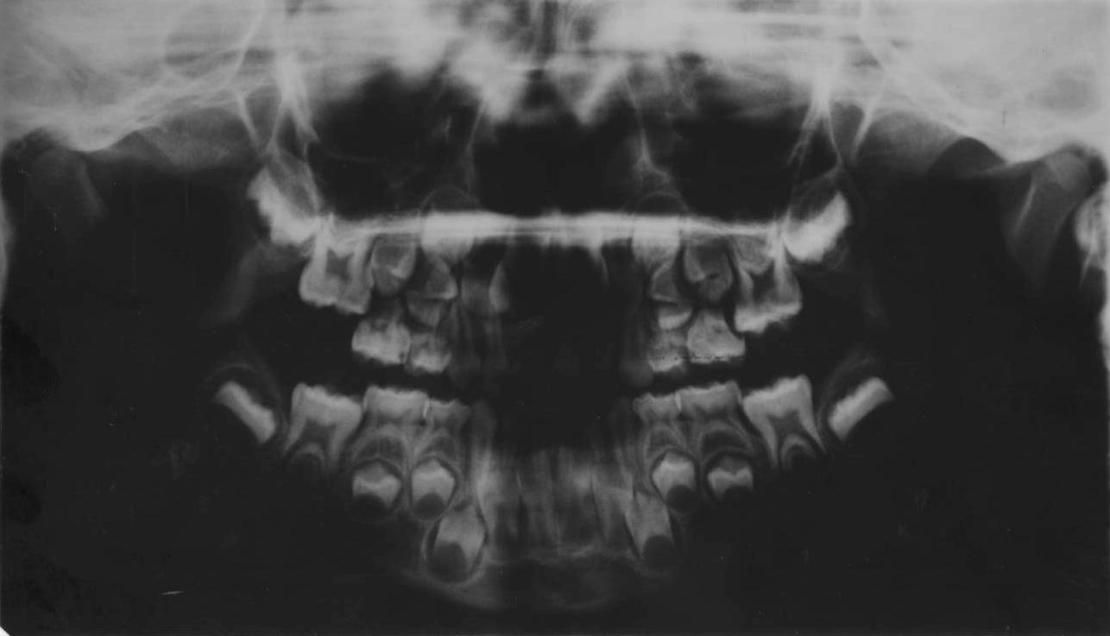

Image 2 OPG at 14 years 10 months

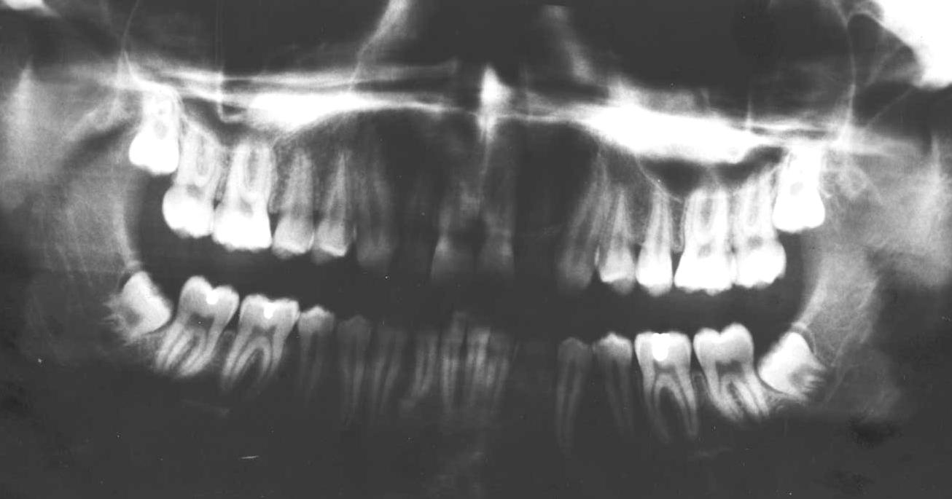

Image 3 OPG at 17 years 2 months

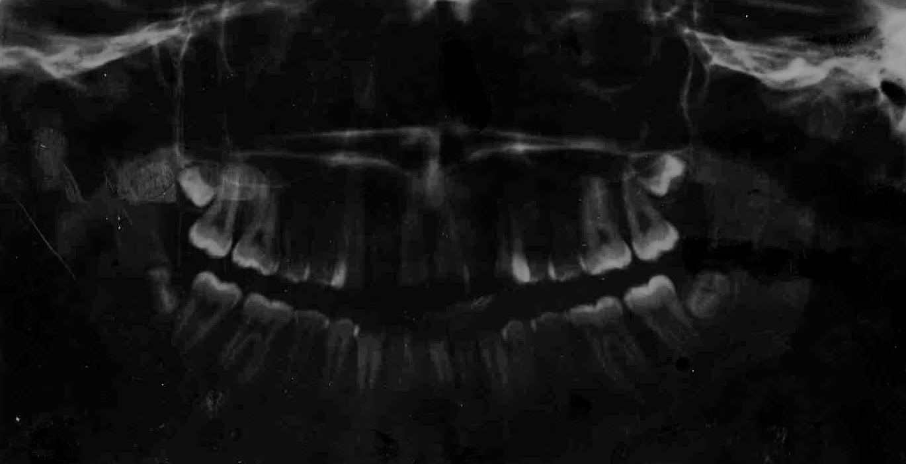

Image 4 OPG at 19 years

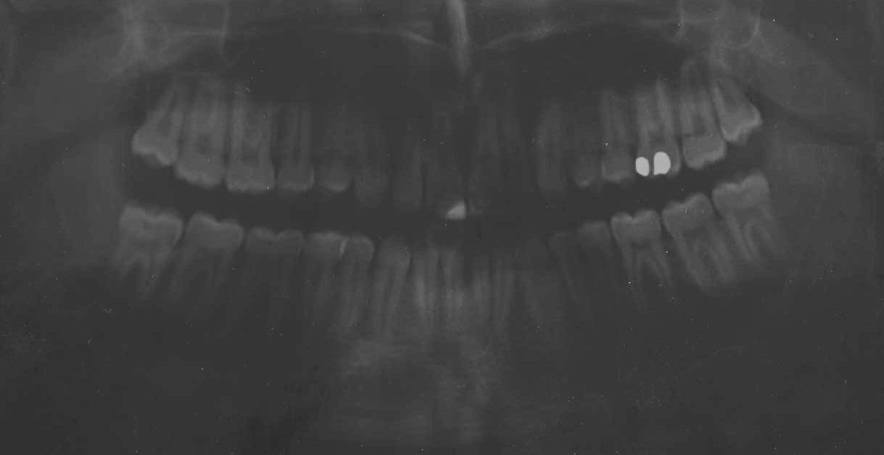

Image 5 OPG Machine

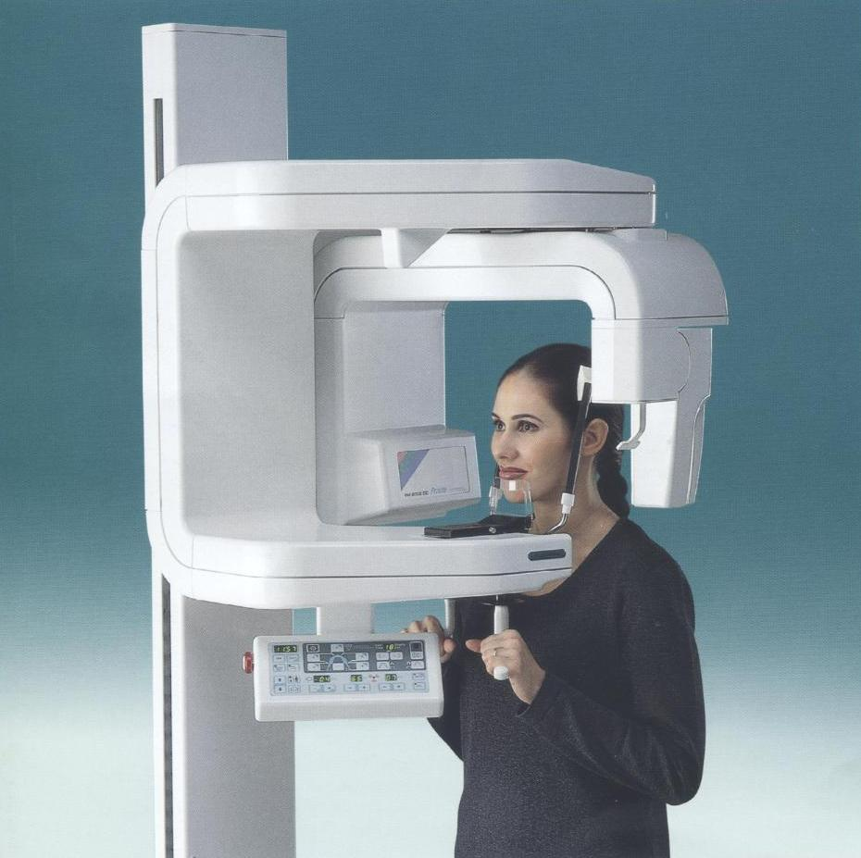

The OPG Radiograph is taken from outside of the mouth.

Image 6 Stages of Crown Root Formation

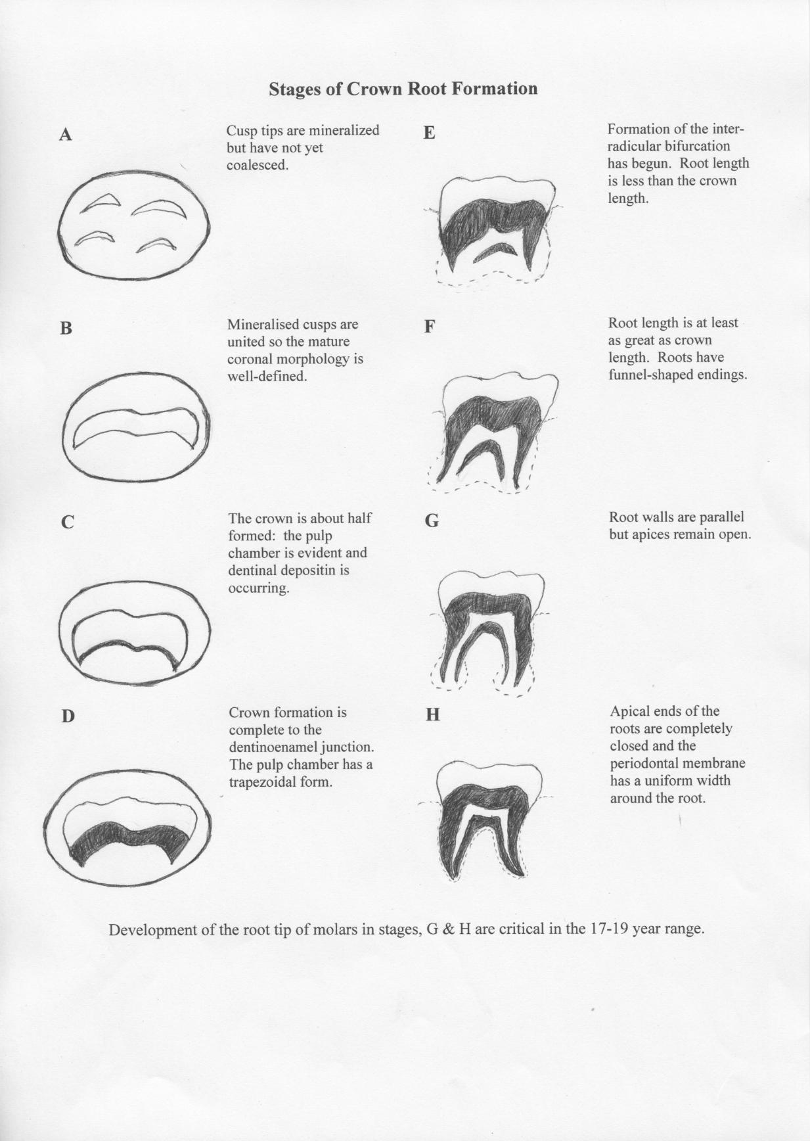

Appendix 1 A Critical Assessment of Human Age at Death Estimation

Medical Sciences Scientific Advisory Group Workshop

Title: A Critical Assessment of Human Age at Death Estimations

Date: 27-28 May 2010

Venue: Adelaide:Forensic Science SA (21 Divett Place) & Forensic Odontology Unit (233 North Terrace)

Duration: 2 days

Numbers: 4 anthropologists and 10 odontologists

Aims:
- Identify similarities and differences of definitions and methods used within and between the disciplines of Forensic Odontology and anthropology
- Achieve a standardized cross-disciplinary approach to the estimation of age at death.

Outcomes:

- Standardized approaches to ageing
- Determine situational uses and potential clients
- Define terminology
- Determine a consensus of age ranges to be used by anthropologists and odontologists
- Discuss methods practitioners use to estimate age at death, advantages and limitations
- Discuss standard report writing and presentation of evidence
- Produce an information package, including ppt for teaching and FAQ for clients
- Discuss research protocol for combine anthropology / odontology project to be prepared for publication of results in scientific literature
- Disseminate workshop outcomes to practicing Australian odontologists and anthropologists

Deliverables:

- Report to Medical Science Scientific Advisory group (MS.SAG)
- Report to Australian Disaster Victim identification Committee (ADVIC)
- Review Australian guidelines
- FAQ Collation
- Literature Collation
- Identify Research gaps / projects
- Disseminate outcomes to odontologists / anthropologists (ANZFSS presentation)

Age Estimation: Frequently Asked Questions

What is an age estimate?

An age estimate is the chronological age range of an individual determined from the analysis of dental, skeletal and other physical characteristics and compared to relevant standards developed from individuals of known age.

In what circumstances may age estimates be useful?

Living
- Refugees and immigrants
- Individual Identification
- Adoption
- Identity theft
- Fraud
- Missing persons
- Amnesia

Deceased
- Individual Identification
- Disaster Victim Identification
- Biological profiling
- Missing persons
- Differentiation of siblings

What are the broad categories for age?

FOETAL 8 wks - Birth
INFANT 0 - <2 yrs
CHILD 2 - <13 yrs
ADOLESCENT 13 - <18 yrs
ADULT 18+ yrs

Why have I been given an age range?
Biological variability. For example, in a classroom of children many will be different heights but will be the same chronological age. The level of biological development of an individual (their biological age) can be affected by many factors including sex, nutrition, ancestry, disease, medical treatment, socio-economic background and other lifestyle factors. This variability increases with age, so the range of an estimate will be narrower in the young and much wider in adults. 16 | P a g e

Are there growth differences between males and females?
Yes. Males and females exhibit different rates of growth and development. This difference becomes more obvious as the child gets older.

Are there differences between races and countries?
Yes. Ancestry, or genetic heritage, plays a significant role in an individual’s rate of growth and development.

Are there recommended guidelines for the process of age estimation?
There is a range of techniques available to the practitioner. The choice of the most appropriate technique will depend on the specific circumstances of the case.

What are the limitations of scientific age estimates?
- A small proportion of people will fall outside the estimated range (about 5%);
- Congenital medical conditions can affect the rate of growth of the teeth and bones and can affect the accuracy of an age estimate;
- Nutrition and lifestyle factors may affect the rates of growth and development and can, in some cases, affect the accuracy of an age estimate;
- Estimates are less accurate in adults and more accurate in children;
- We need the appropriate bones and/or teeth to provide an age estimation. The accuracy of age estimations are affected by the completeness and preservation of the remains;
- There is not always the relevant dataset for a particular population, which means a similar (or ‘next best’) dataset will be used resulting in a less accurate estimate.

Can you estimate age of an individual from another country?
Yes. Ideally a relevant comparative dataset from the country of origin of the individual will be used for an estimation. If such a dataset does not exist the next most relevant dataset will be used. However, this will result in an estimate with a larger age range allowing for the variation between countries and ancestries.

Appendix 2 Schour & Massler Atlas

Appendix 3 Blenkin & Taylor Atlas

Appendix 4 Al Quhtani Atlas

Appendix 5 Radiation Dosage

Ref – RadiologyInfo.org: Radiation Exposure in X-ray and CT Examinations

Appendix 6 Draft Report – Generic

Draft Age Assessment Report

Date

Re: Name

Address

Dear Sir,

At the request of …….Name....…from,…….Organisation..…….., and with written consent from.…Name..….and his legal representative, I arranged a referral for..…….Name…....to have an OrthoPantomoGraph (OPG) and/or Hand/Wrist radiograph to be taken at …….Radiography Department…… on Date

The radiographic images taken were forwarded to my office on the ………Date…………….

As background information, the human dentition develops from a process of calcification of embryonic membranous tissue, commonly called ‘tooth germs’. Calcification of the tissue commences prior to birth and is complete in early adult life with the calcification of the root apex of the third permanent (adult) molar tooth - (wisdom tooth).

The OPG radiograph is viewed to:

- evaluate the dental health status of the dentition; a complete clinical oral examination is required to confirm the status of the oral health of the client
- assess the age of the client

The chronological age assessment is determined by comparing the stages of calcification of all teeth and ‘tooth germs’ present on the OPG image with relevant published data from individuals of known age (list attached). The chronological age assessment is expressed as an age range, with confidence intervals.

I forwarded the images to Specialist Forensic colleagues ………………..Insert Names …………………………for their review and comment.

An analysis of the teeth and bone images viewed showed… Unremarkable/Revealed anomalies ……….

Note: All abnormal findings are to be reported and recommendations for further investigation must be made. Any follow-up treatment would be the responsibility of the client who had the OPG taken to arrange.
Evaluating the status of the teeth present with published data on age assessment (as per the list attached) we assess the age of ……..…Name………… at the date the radiographs were taken to be ………… with a range of …+/-…… months.

If additional information is required please contact myself on the above address or by phone

Yours sincerely,

Dr ………………Name………………..
…………………….Title……………
…………………Position
Attached:
Reference list
Reviewers’ Addresses

